# Enter-Exit System (BCG Shared Assets)

Supports all BCG vehicle controllers at the moment. Enables / disables character controllers, registers / deregisters vehicles, and observes all events.

First, you have to import “**BCG Shared Assets**” into your project in order to use enter / exit system. It will add necessary scripts and resources to use your FPS or TPS player for enter / exit vehicles. Package is located in “**Addon Packages\For BCG Shared Assets (Enter-Exit)**” folder. You can also import integration package from welcome window too. **Tools 🡪 BCG 🡪 RCC 🡪 Welcome Window 🡪 Addons**.

There will be two new scenes imported to the “**Demo Scenes**” folder. One for FPS, and the other one for TPS controllers. FPS and TPS controllers are using different cameras. Usually, camera of the FPS character is in the gameobject. But TPS characters have unattached and independent cameras, and they are not parented to the character. Therefore**, BCG_EnterExitPlayer.cs** script has two options for usement with FPS or TPS. If TPS is choosen, you must declare the TPS camera in the scene.

You can edit some settings from (**Tools 🡪 BCG 🡪 Shared Assets 🡪 Edit Settings**).

metin içeren bir resim

Açıklama otomatik olarak oluşturuldu

# How The System Works (Simple)

All RCC vehicles have “**BCG_EnterExitVehicle**” component. And our **FPS/TPS** character has “**BCG_EnterExitPlayer**” component. **BCG_SceneManager (Will be created automatically)** will be observing all vehicles and your character in the scene. If vehicle has no driver, \***canControl** of the vehicle will be disabled, and not registered as player vehicle. If our character has entered any vehicle, **BCG_SceneManager** will register the target vehicle as player vehicle, enables the canControl of the vehicle. At that moment, our character will be parented to the vehicle and disabled entirely. Now, **BCG_EnterExitVehicle** has a \*\***driver** now. If player gets out from the vehicle, **BCG_SceneManager** will be activating character controller, and transport it to “**Get Out Pos**” of the vehicle. And lastly, deregister the vehicle and disable \***canControl** of the vehicle. Now, vehicle is not controllable, not a player vehicle.

* = **canControl** bool of the **RCC_CarControllerV3**. If it’s enabled, the vehicle is controllable.

** = **driver** variable of the **BCG_EnterExitVehicle**.

# How To Make It Work

All you have to do is, add necessary scripts to the vehicles and to your player. Get out position of the vehicles are created automatically in script if you don’t select it in **BCG_EnterExitCar**. You can replace get out positions.

For FPS characters, it will depend on your camera of the FPS player. For TPS player, it depends on your actual TPS Player, not camera.

Character Controllers must have **BCG_EnterExitPlayer**

Vehicles must have **BCG_EnterExitVehicle**

**_BCGEnterExitManager** will be created automatically in your scene. **_BCGEnterExitManager** will be managing all the process.

# How The System Works (Detailed)

Please read simple version first if you haven’t read. Let’s get it straigth with more detailed version;

1. BCG_EnterExitVehicle – must be attached to all vehicles.
2. BCG_EnterExitPlayer – must be attached to the character.
3. BCG_EnterExitManager – will be created automatically.

All the system is based on events. **BCG_EnterExitPlayer** is firing an event when it’s spawned, destroyed, gets in a vehicle, or gets out of the vehicle. **BCG_SceneManager** will be listening to this event as well. So, manager knows your all of your character events. All events are explained below;

public delegate void **onBCGPlayerSpawned**(BCG_EnterExitPlayer player);

public delegate void **onBCGPlayerDestroyed**(BCG_EnterExitPlayer player);

public delegate void **onBCGPlayerEnteredAVehicle**(BCG_EnterExitPlayer player, BCG_EnterExitVehicle vehicle);

public delegate void **onBCGPlayerExitedFromAVehicle**(BCG_EnterExitPlayer player, BCG_EnterExitVehicle vehicle);

You can listen any events on the **BCG_EnterExitPlayer or BCG_EnterExitVehicle**. For example;

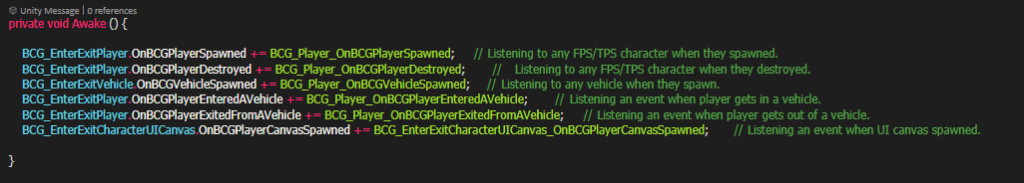

Nice color scheme, isn’t it? 😊 Anyways, **BCG_EnterExitManager** will use using **GetIn()** or **GetOut()** methods by listening these events. **GetIn()** method requires “**targetVehicle**”. **GetOut()** method doesn’t require any parameters.

When our character standing next to the any vehicle, get in text will be enabled by **BCG_EnterExitPlayer**. If player pushes the interaction button, **OnBCGPlayerEnteredAVehicle** event will be fired with targetVehicle data. As you well now, this event has been listening by **BCG_SceneManager**. So, **BCG_SceneManager** will be firing **GetIn(targetVehicle)** method to do the rest.